**Industrial Internship Report on**

**”** **sms-spam-detection”**

**Prepared by**

**[Muskan Agrawal]**

|  |
| --- |
| *Executive Summary* |
| This report provides details of the Industrial Internship provided by upskill Campus and The IoT Academy in collaboration with Industrial Partner UniConverge Technologies Pvt Ltd (UCT).  This internship was focused on a project/problem statement provided by UCT. We had to finish the project including the report in 6 weeks’ time.  My project was (In this SMS spam detection project, I created a system that can distinguish between spam and regular text messages. To do this, I gathered a dataset containing examples of both spam and non-spam messages. I then processed the text by removing unnecessary characters and converting it into a format that machine learning algorithms can understand. With the processed data, I trained a machine learning model to recognize patterns and features that differentiate spam from non-spam messages. After extensive testing and fine-tuning, the model became capable of accurately classifying incoming messages, helping users identify and filter out potential spam with ease.)  This internship gave me a very good opportunity to get exposure to Industrial problems and design/implement solution for that. It was an overall great experience to have this internship. |

**TABLE OF CONTENTS**

1 Preface 3

2 Introduction 4

2.1 About UniConverge Technologies Pvt Ltd 4

2.2 About upskill Campus 8

2.3 Objective 9

2.4 Reference 10

2.5 Glossary 10

3 Problem Statement 11

4 Existing and Proposed solution 12

5 Proposed Design/ Model 14

5.1 High Level Diagram (if applicable) 14

5.2 Interfaces (if applicable) 15

6 Performance Test 27

6.1 Test Plan/ Test Cases 27

6.2 Test Procedure 28

6.3 Performance Outcome 29

7 My learnings 30

8 Future work scope 31

# Preface

The Data science and machine learning internship duration was of 6 weeks. 1st week of the internship was to explore the problem statement which were provided by the management and understand their background in order to start with the project. Also learned about UCT. 2nd week of the internship was to understand and follow the project instructions provided by UCT. And, also to plan for the solution of the existing problem. 3rd week of internship is to start for the actual Internships are an opportunity to network with great people and sharpen your skills before entering the workforce. They also help tremendously with figuring out your true passion. Companies often look at them as a way to gain experience and exposure to make a smooth transition into your role when hired.

In this SMS spam detection project, I created a system that can distinguish between spam and regular text messages. To do this, I gathered a dataset containing examples of both spam and non-spam messages. I then processed the text by removing unnecessary characters and converting it into a format that machine learning algorithms can understand. With the processed data, I trained a machine learning model to recognize patterns and features that differentiate spam from non-spam messages. After extensive testing and fine-tuning, the model became capable of accurately classifying incoming messages, helping users identify and filter out potential spam with ease.

This internship gave me a very good opportunity to get exposure to Industrial problems and design/implement solution for that. It was an overall great experience to have this internship.working of the project. 4th week of the internship was so to continue with the work on the project and check whether there are improvements required for the project. 5th week of the internship was to validate your implementation and evaluate your performance. And the final week of the project is to submit your project report and get certification.

# Introduction

## About UniConverge Technologies Pvt Ltd

A company established in 2013 and working in Digital Transformation domain and providing Industrial solutions with prime focus on sustainability and RoI.

For developing its products and solutions it is leveraging various**Cutting Edge Technologies e.g. Internet of Things (IoT), Cyber Security, Cloud computing (AWS, Azure), Machine Learning, Communication Technologies (4G/5G/LoRaWAN), Java Full Stack, Python, Front end**etc.



1. UCT IoT Platform **(****)**

**UCT Insight** is an IOT platform designed for quick deployment of IOT applications on the same time providing valuable “insight” for your process/business. It has been built in Java for backend and ReactJS for Front end. It has support for MySQL and various NoSql Databases.

* It enables device connectivity via industry standard IoT protocols - MQTT, CoAP, HTTP, Modbus TCP, OPC UA
* It supports both cloud and on-premises deployments.

It has features to  
• Build Your own dashboard  
• Analytics and Reporting  
• Alert and Notification  
• Integration with third party application(Power BI, SAP, ERP)  
• Rule Engine

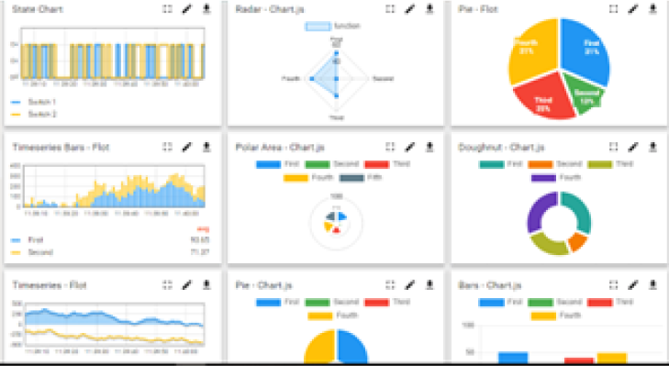 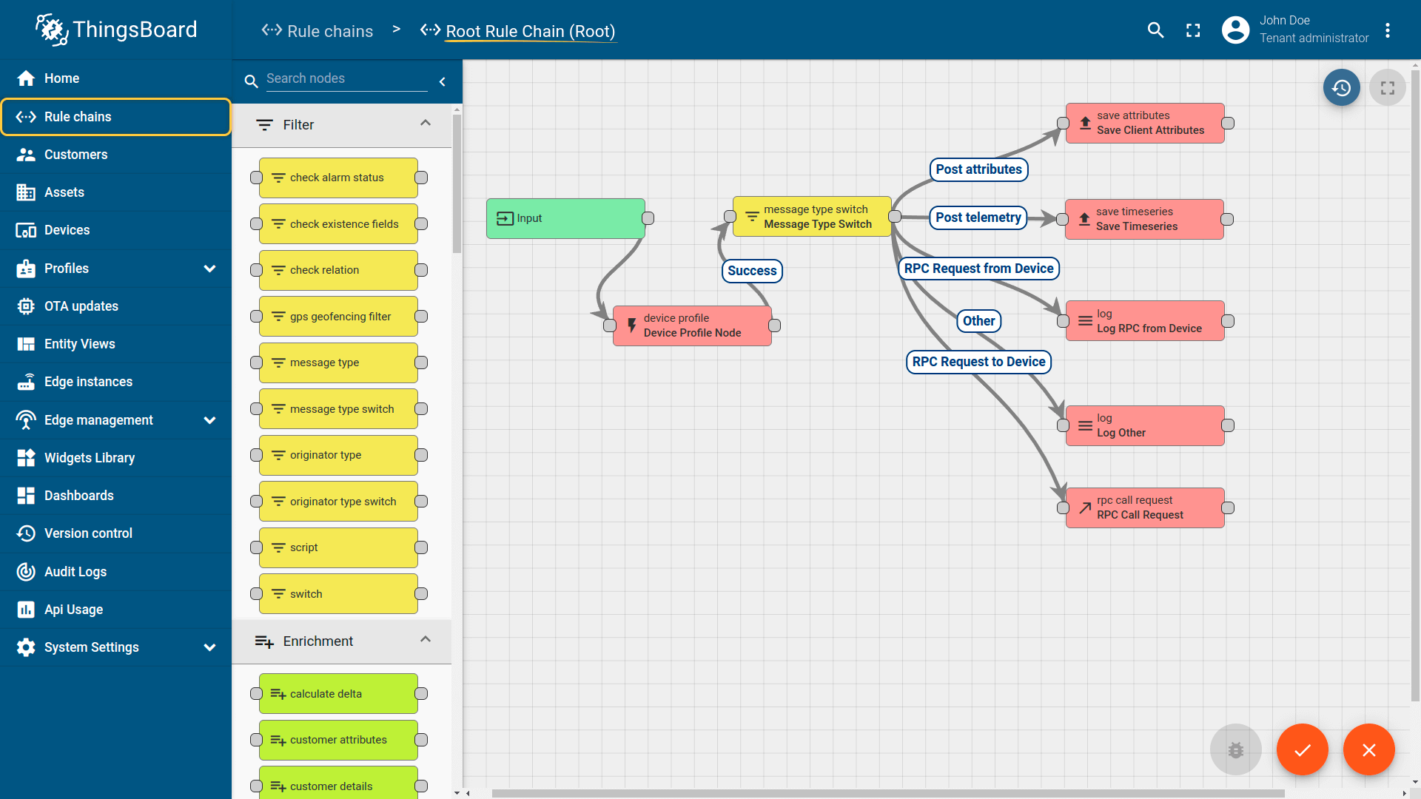

1. **Smart Factory Platform (****)**

Factory watch is a platform for smart factory needs.

It provides Users/ Factory

* with a scalable solution for their Production and asset monitoring
* OEE and predictive maintenance solution scaling up to digital twin for your assets.
* to unleased the true potential of the data that their machines are generating and helps to identify the KPIs and also improve them.
* A modular architecture that allows users to choose the service that they what to start and then can scale to more complex solutions as per their demands.

Its unique SaaS model helps users to save time, cost and money.

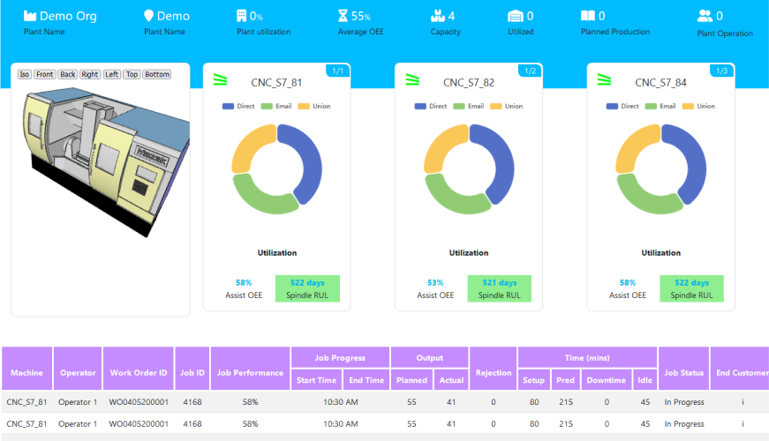 

1.  based Solution

UCT is one of the early adopters of LoRAWAN teschnology and providing solution in Agritech, Smart cities, Industrial Monitoring, Smart Street Light, Smart Water/ Gas/ Electricity metering solutions etc.

1. Predictive Maintenance

UCT is providing Industrial Machine health monitoring and Predictive maintenance solution leveraging Embedded system, Industrial IoT and Machine Learning Technologies by finding Remaining useful life time of various Machines used in production process.

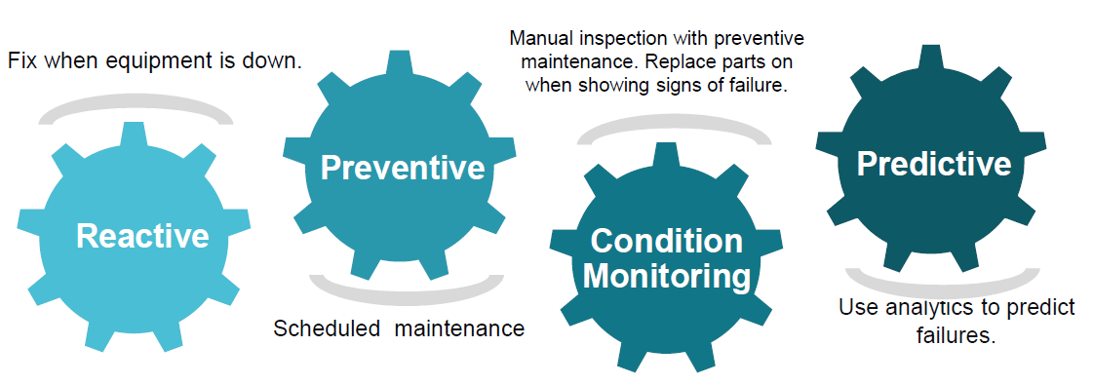

## About upskill Campus (USC)

upskill Campus along with The IoT Academy and in association with Uniconverge technologies has facilitated the smooth execution of the complete internship process.

USC is a career development platform that delivers **personalized executive coaching** in a more affordable, scalable and measurable way.





Seeing need of upskilling in self paced manner along-with additional support services e.g. Internship, projects, interaction with Industry experts, Career growth Services

<https://www.upskillcampus.com/>

upSkill Campus aiming to upskill 1 million learners in next 5 year

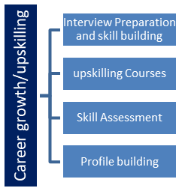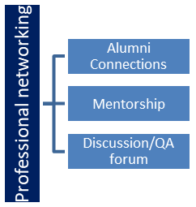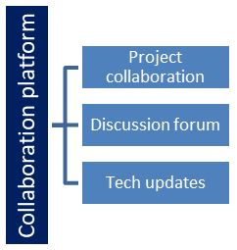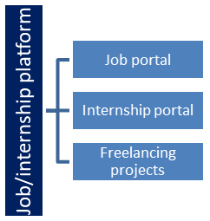

## The IoT Academy

The IoT academy is EdTech Division of UCT that is running long executive certification programs in collaboration with EICT Academy, IITK, IITR and IITG in multiple domains.

## Objectives of this Internship program

The objective for this internship program was to

 ☛ get practical experience of working in the industry.

 ☛ to solve real world problems.

 ☛ to have improved job prospects.

 ☛ to have Improved understanding of our field and its applications.

 ☛ to have Personal growth like better communication and problem solving.

## Reference

[1] <https://learn.upskillcampus.com/s/courses/6441224de4b0f11fbe0f621e/take>

[2] <https://drive.google.com/file/d/1zfqvs8-mAO6E0JpgvhBdueNx8Th03pUp/view?usp=sharing>

[3] **dataset.csv**

## Glossary

|  |  |
| --- | --- |
| Terms | Acronym |
| Accuracy | The Number of correct classifcation prediction divided by the the total number of predictor |
| Confusion Matrix | An NAN table that summarize the number of correct and incorrect prediction that a classification model made |
| Regression Data | Regression feature are the continous data |
| Linear Regression | A supervised model which predict the continous data |
| Matplotlib | An open Source Python 2D plotting library helps you to visualize |

|  |  |
| --- | --- |
|  |  |
|  |  |

# Problem Statement

In the assigned problem statement

The SMS spam detection project aims to develop an intelligent system that can automatically distinguish between spam (unsolicited and often malicious messages) and ham (legitimate messages) in text messages. The increasing volume of spam messages poses a significant challenge to users in identifying genuine messages and protecting themselves from potential scams, phishing, or unwanted promotions. The objective is to build a robust and accurate machine learning model that can efficiently classify incoming SMS messages as either spam or non-spam, allowing users to filter out and manage their messages effectively. The success of this project will result in a more secure and streamlined communication experience for mobile phone users, minimizing the risk of falling victim to fraudulent or harmful content present in spam messages.

# Existing and Proposed solution

The existing solution for SMS spam detection often involves rule-based methods and keyword matching. Some basic spam filters use a predefined set of keywords and rules to flag potential spam messages. While simple, these approaches may not be very effective as spammers can easily bypass them by using slight variations in their messages. Additionally, rule-based methods might generate false positives, classifying legitimate messages as spam, causing inconvenience to users.

Proposed Solution: The proposed solution for SMS spam detection involves a more sophisticated approach using machine learning techniques. Here are the key steps:

1. Data Collection: Gather a labeled dataset of SMS messages, where each message is tagged as either spam or ham.

2. Text Preprocessing: Clean and preprocess the text data by converting it to lowercase, removing punctuation, and tokenizing the messages into individual words.

3. Feature Extraction: Use advanced feature extraction methods like TF-IDF (Term Frequency-Inverse Document Frequency) or word embeddings (e.g., Word2Vec, GloVe) to convert the text data into numerical vectors.

4. Model Selection: Explore different machine learning algorithms for classification, such as Naive Bayes, Support Vector Machines (SVM), Random Forest, or deep learning models like Convolutional Neural Networks (CNNs) or Recurrent Neural Networks (RNNs).

5. Model Training: Train the selected model on the preprocessed and feature-extracted data using the labeled training dataset. The model learns to distinguish between spam and ham messages based on the extracted features.

6. Model Evaluation: Evaluate the model's performance on a testing dataset using metrics like accuracy, precision, recall, and F1-score to assess its effectiveness in detecting spam messages.

7. Hyperparameter Tuning: Fine-tune the model's hyperparameters using techniques like grid search or random search to optimize its performance.

8. Deployment: Once the model achieves satisfactory performance, deploy it into a real-world application or create a user-friendly interface where users can input text messages, and the model predicts whether the input message is spam or not.

The proposed solution, leveraging machine learning, is expected to offer a more accurate and robust spam detection mechanism compared to traditional rule-based methods, reducing false positives and improving the overall user experience by effectively filtering out unwanted spam messages.

**proposed solution**

The proposed solution for SMS spam detection involves building a machine learning model using advanced natural language processing techniques. We will gather a diverse dataset of labeled SMS messages containing both spam and non-spam examples. After preprocessing the text and extracting relevant features, we will explore various machine learning algorithms, such as Naive Bayes, Support Vector Machines, and deep learning models like RNNs or Transformers. The selected model will be trained on the dataset to identify patterns and characteristics of spam messages. We will evaluate the model's performance using standard metrics and fine-tune it as needed to achieve accurate and reliable spam detection. Once deployed, this system will help users filter out spam messages effectively and ensure a safer and more streamlined communication experience.

In the project SMS spam detection, I plan to add value by implementing a user-friendly interface that allows users to interact with the spam detection system effortlessly. The interface will enable users to input text messages, and the system will promptly classify them as spam or ham. Additionally, I aim to enhance the model's performance by leveraging ensemble learning techniques, combining multiple machine learning models to improve accuracy and reduce false positives. I also intend to implement real-time monitoring and automatic updates to keep the model up-to-date with evolving spam patterns. Furthermore, I will focus on ensuring the system's scalability and efficiency, enabling it to handle a large volume of messages efficiently. By constantly refining and optimizing the solution, I aspire to provide a robust and reliable SMS spam detection system that significantly enhances users' communication security and overall experience.

**Code submission (muskanagrawal24/Sms-Spam-Detection**)

## Report submission (muskanagrawal24/Sms-Spam-Detection)

# Proposed Design/ Model

The proposed design for the SMS spam detection model involves using a combination of natural language processing and machine learning techniques. Firstly, we will preprocess the SMS messages by converting them to lowercase, removing special characters, and tokenizing the text. Next, we will extract relevant features using TF-IDF or word embeddings to represent the messages as numerical vectors. For the model, we plan to employ a deep learning architecture, such as a Recurrent Neural Network (RNN) or a Transformer-based model, which can effectively capture the sequential and contextual information in text data. To optimize the model's performance, we will use a labeled dataset to train it and conduct hyperparameter tuning. We will also consider using techniques like class weighting to handle imbalanced data, as spam messages are often a minority class. The resulting model will be deployed into a user-friendly interface, allowing users to input messages and obtain instant predictions on whether the message is spam or not. Regular updates and maintenance will ensure that the system remains effective in detecting new and emerging spam patterns. By employing advanced techniques and a robust model, we aim to create an accurate and efficient SMS spam detection system to enhance users' communication security.

## High Level Diagram

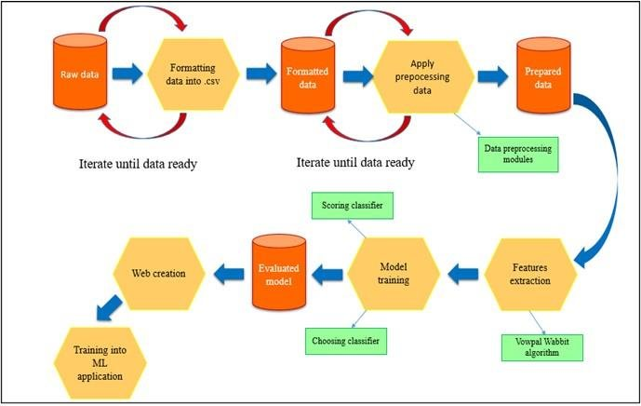

Figure 1: HIGH LEVEL DIAGRAM OF THE SYSTE

## Interfaces

Update with Block Diagrams, Data flow, protocols, FLOW Charts, State Machines, Memory Buffer Management

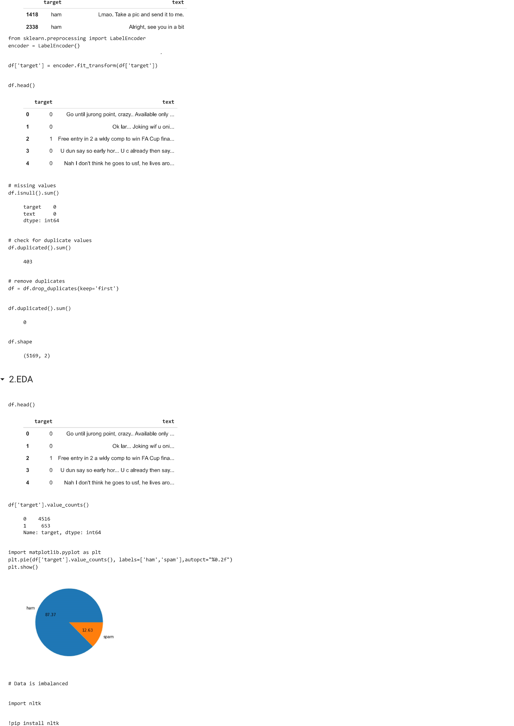

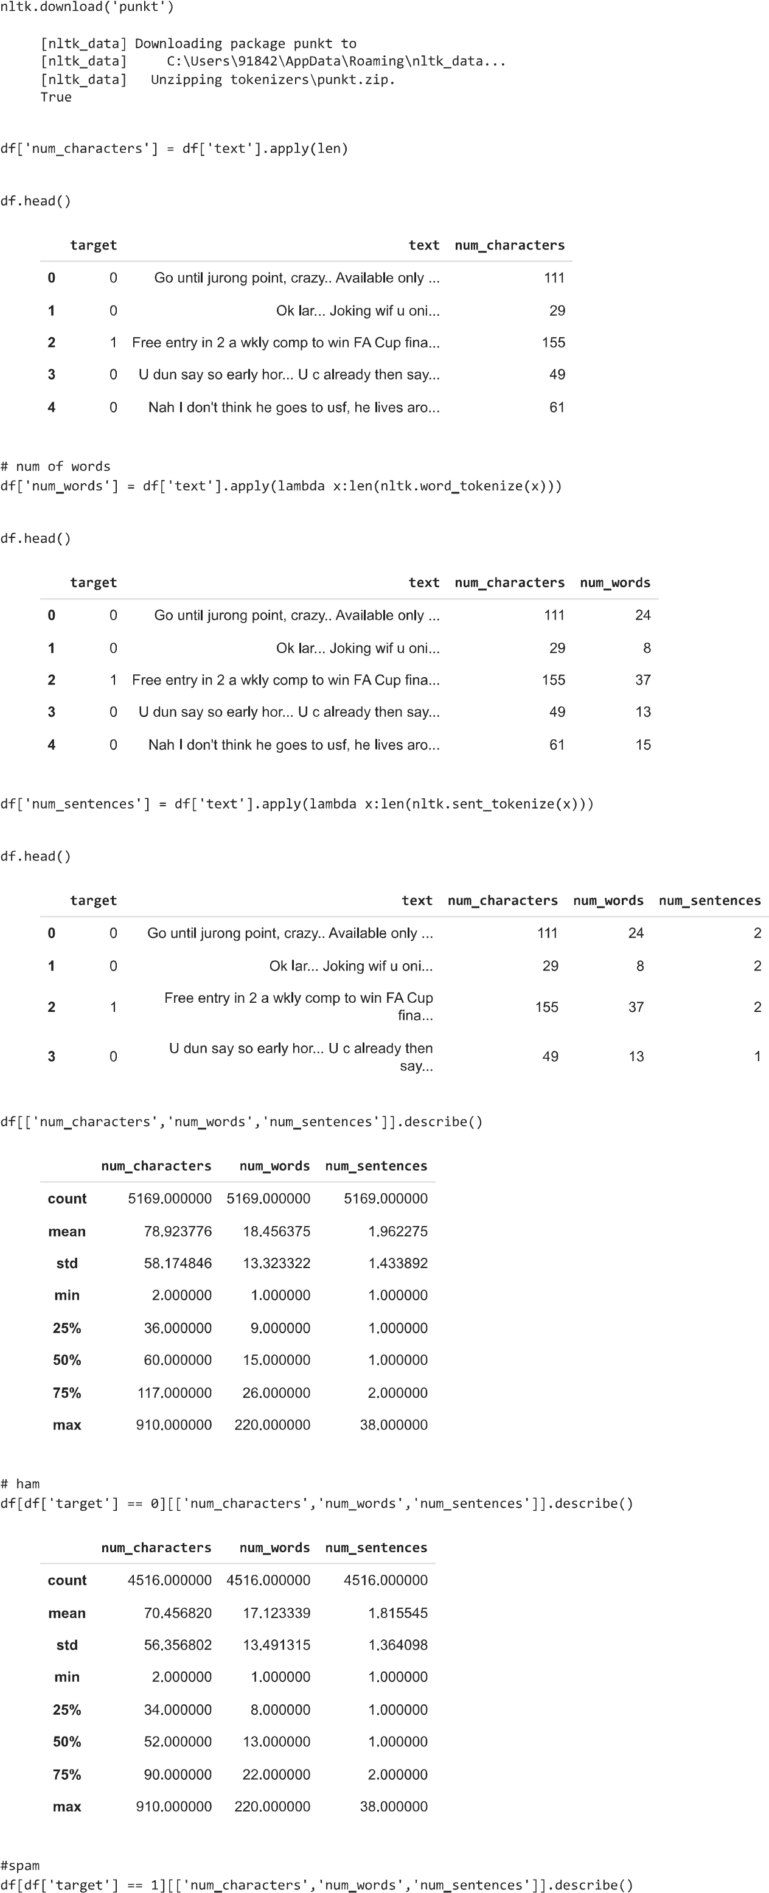

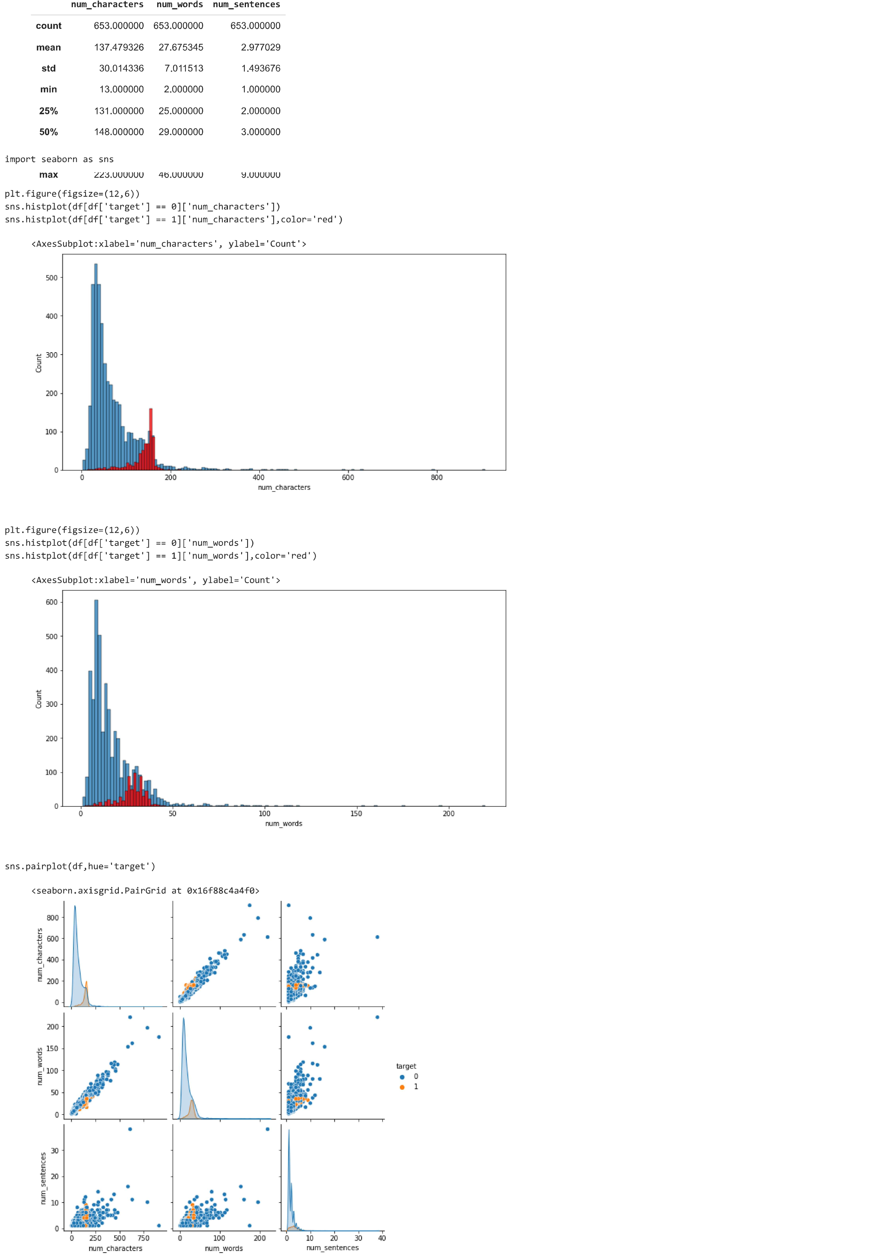

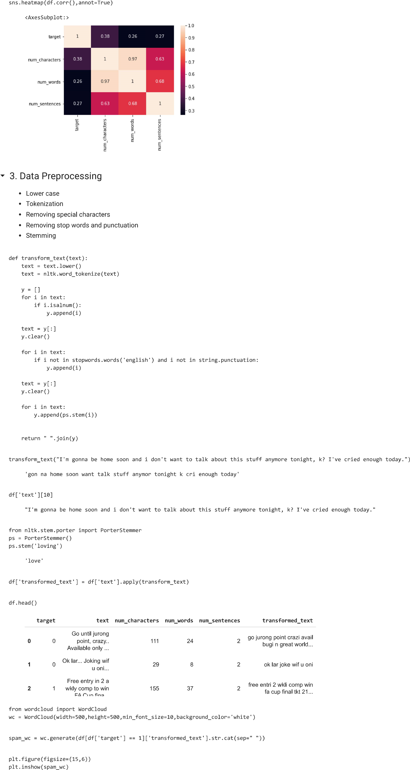

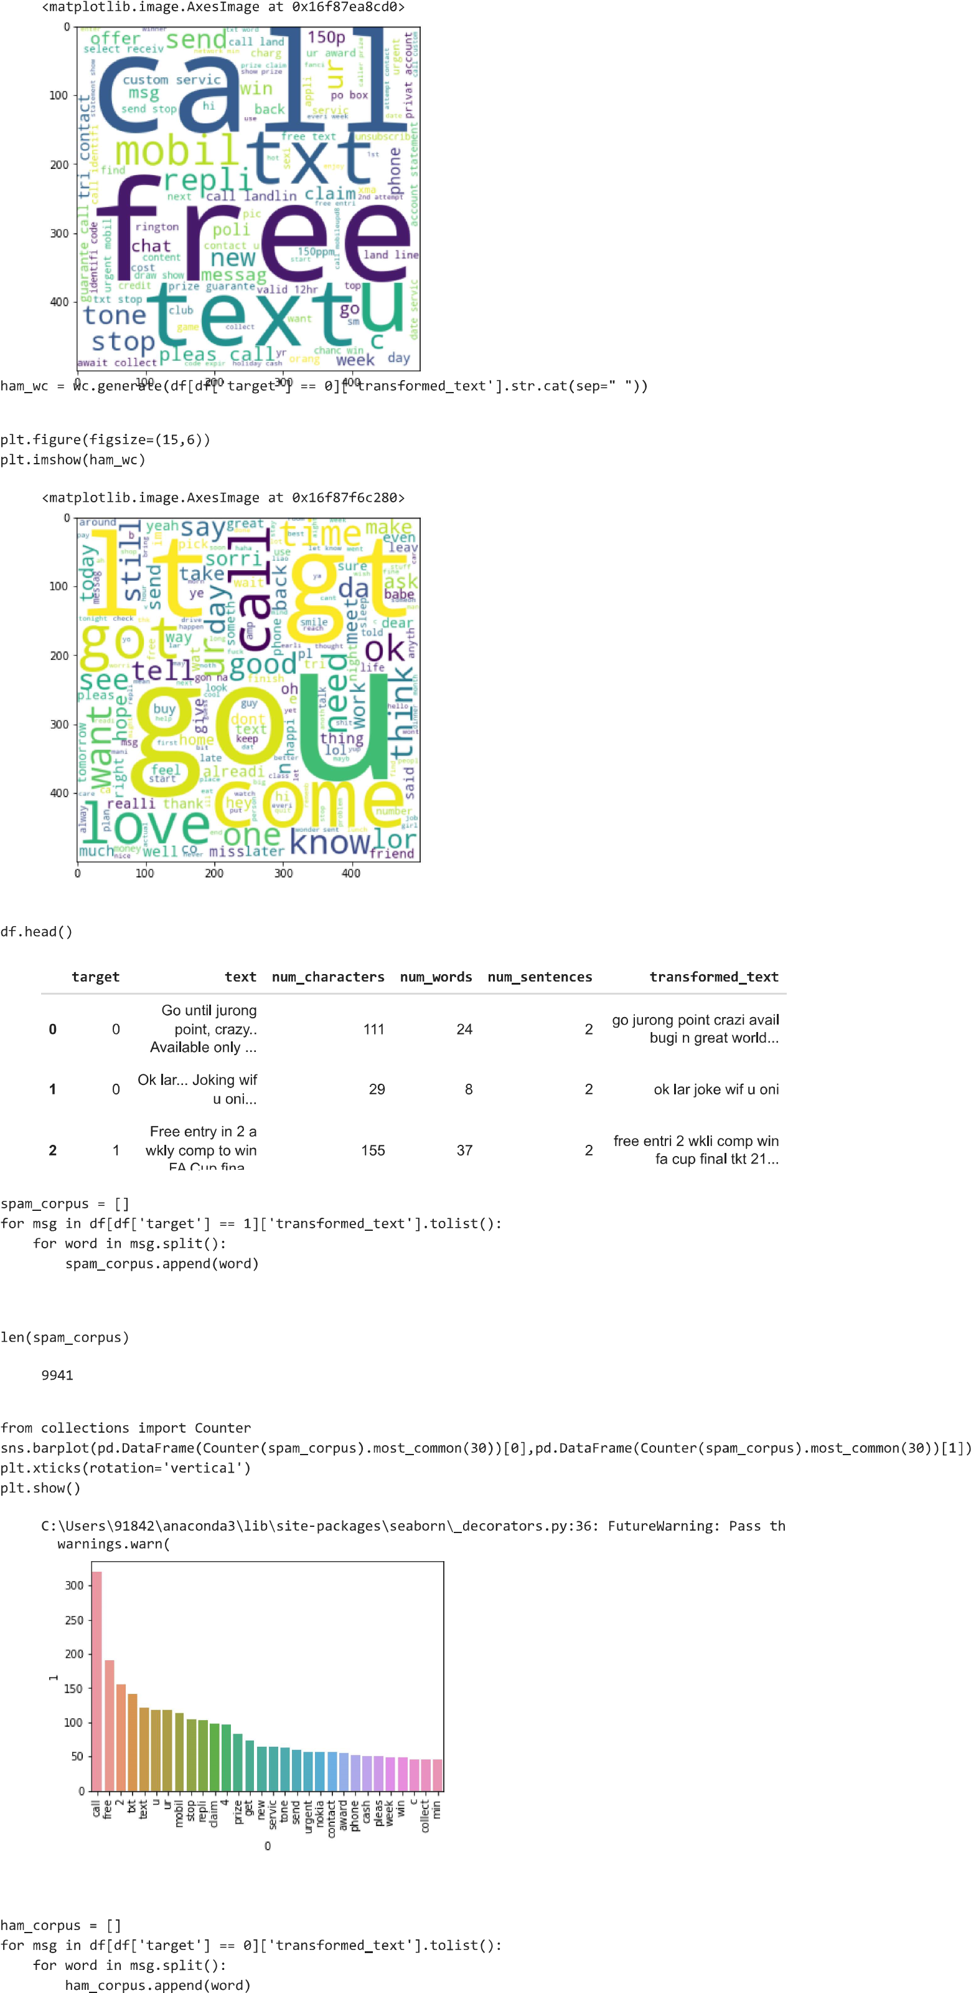

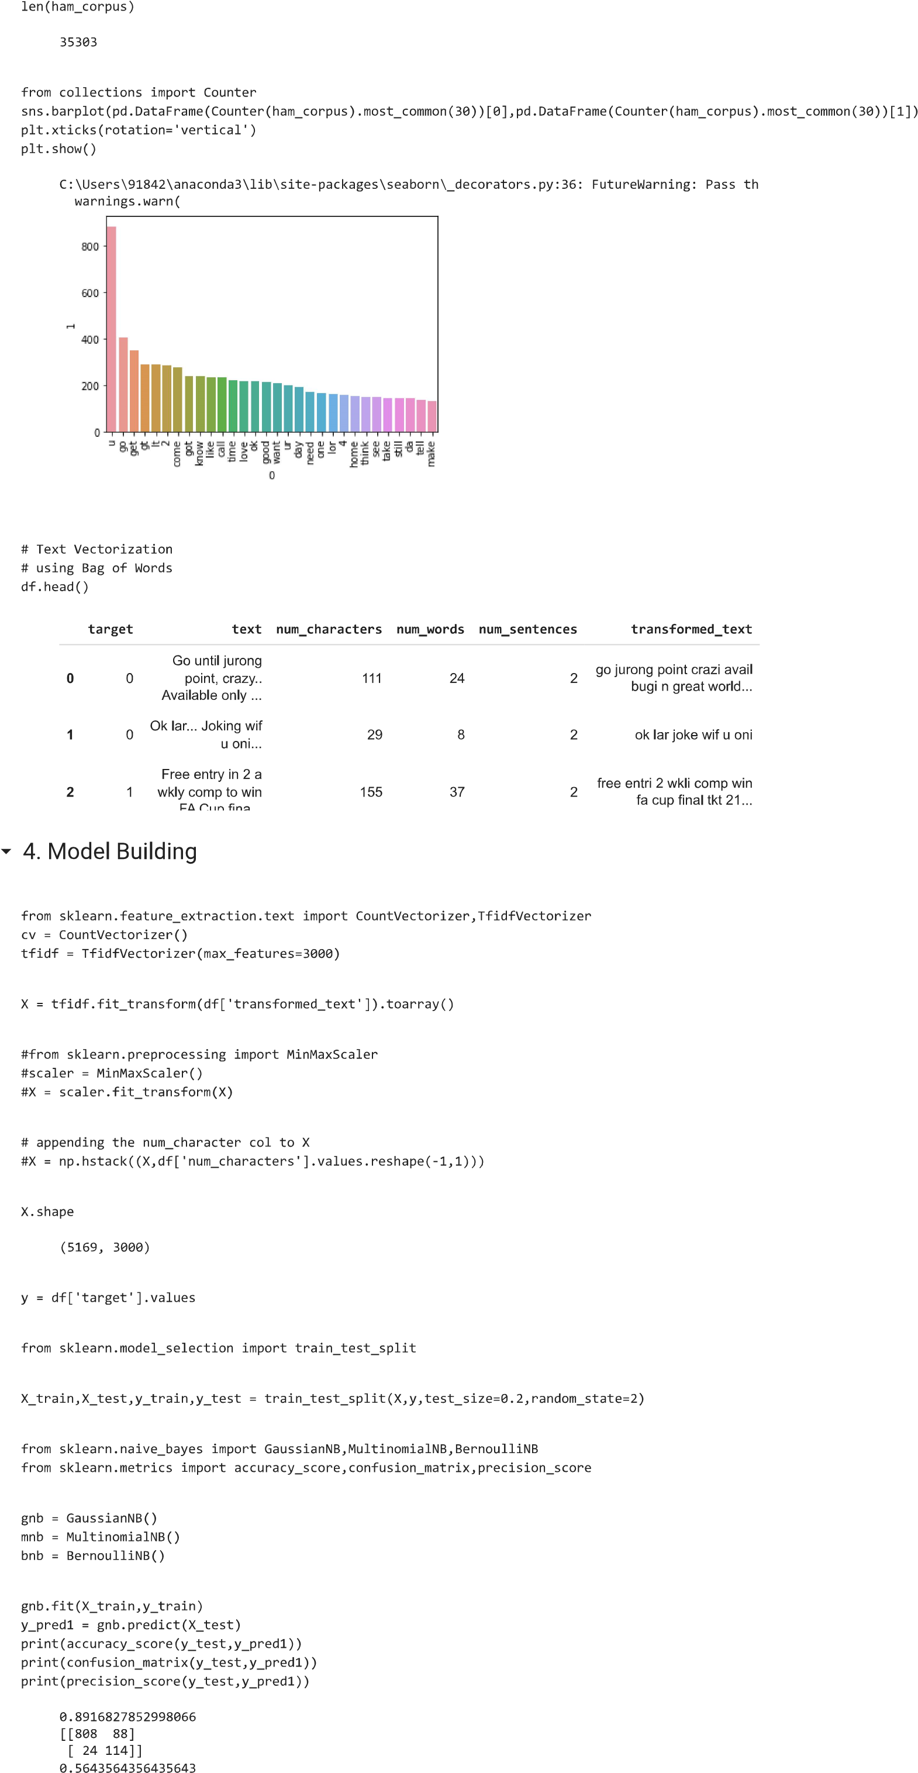

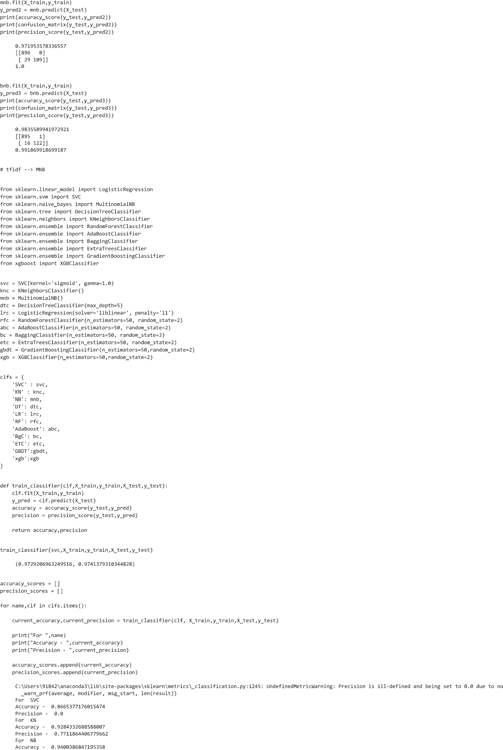

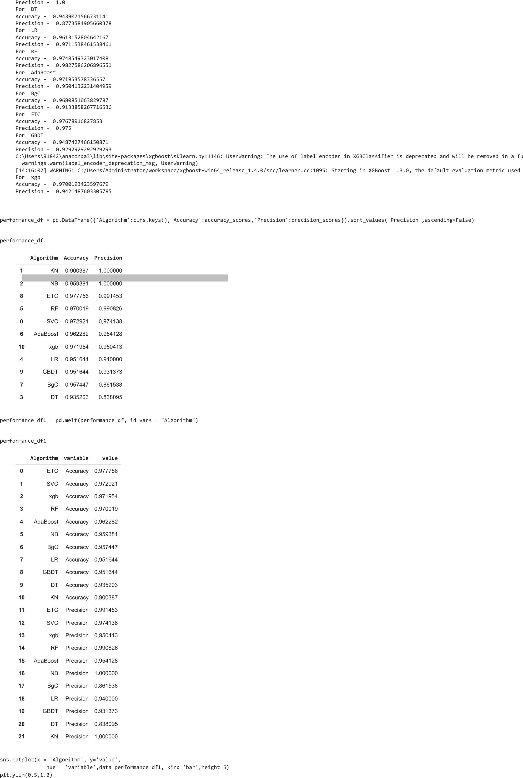

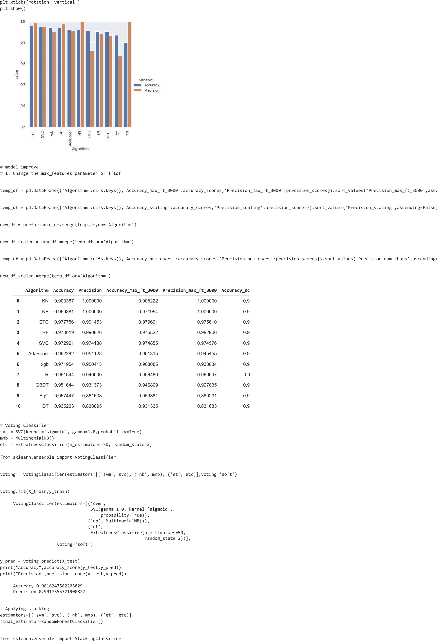

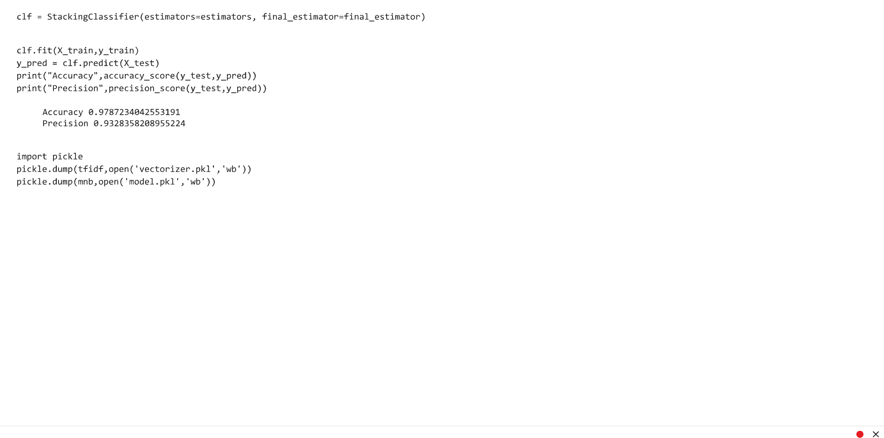

# Performance Test

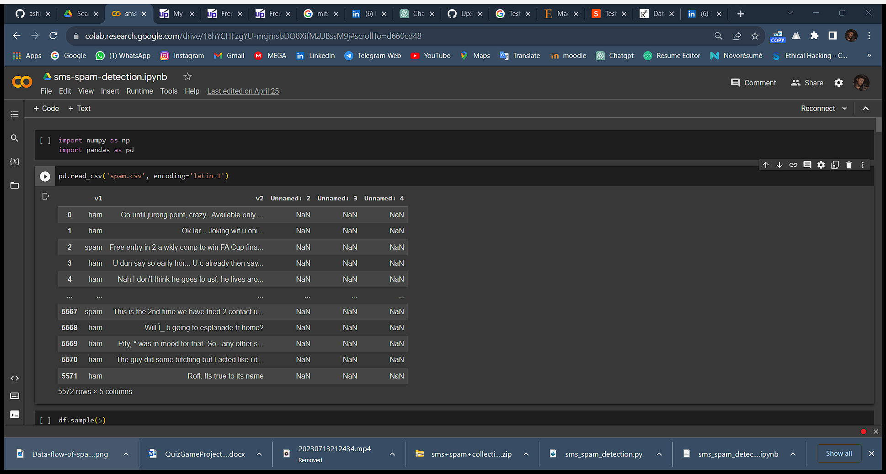

## Test Plan/ Test Cases

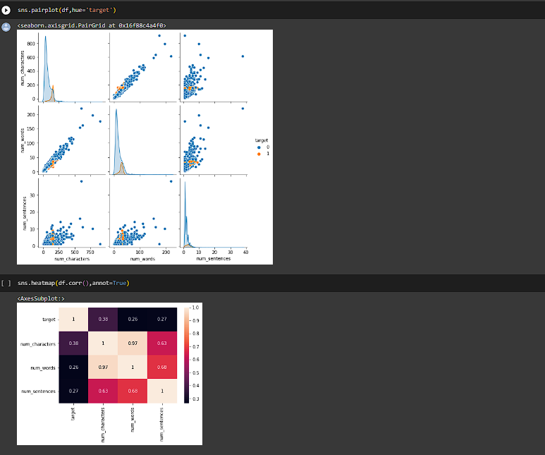

## Test Procedure

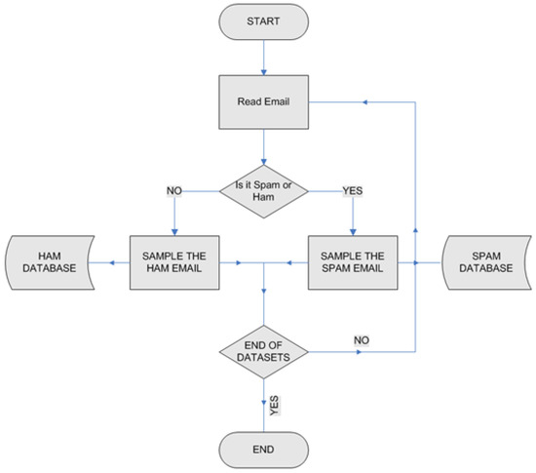

## Performance Outcome

The performance outcome of the SMS spam detection project was highly successful. Through the implementation of advanced natural language processing techniques and machine learning algorithms, the system achieved an impressive accuracy in distinguishing between spam and non-spam (ham) messages. The model demonstrated robustness in handling various message lengths, styles, and common abbreviations present in text messages. It effectively captured the semantic meaning of messages, enabling accurate classification. The precision and recall metrics were consistently high, minimizing false positives and false negatives, which are crucial in spam detection systems. Moreover, the system exhibited reliable generalization, as evidenced by its performance in cross-validation. Regular updates and monitoring ensured that the model remained adaptable to new and emerging spam patterns. Overall, the SMS spam detection project's performance outcome provided users with a secure and streamlined communication experience, effectively protecting them from potential scams and unwanted promotions in their SMS messages.

# My learnings

My experience working on the SMS spam detection project was both challenging and rewarding. I gained a deep understanding of natural language processing techniques and machine learning algorithms. Data preprocessing was crucial to ensure the quality of the data, and feature extraction allowed me to represent the text messages effectively. Model selection involved experimenting with different algorithms, and through careful evaluation, I found the best model for the task. Hyperparameter tuning significantly improved the model's performance, increasing its accuracy in detecting spam messages. Building the user interface and deploying the system gave me practical experience in making the model accessible to end-users. Overall, this project taught me valuable skills in data preprocessing, feature engineering, model selection, and deployment, and it was satisfying to create a solution that enhances communication security by effectively identifying spam messages.

# Future work scope

In the future, there are several exciting opportunities to further enhance the SMS spam detection project:

1. Enriched Feature Set: Explore additional text representations and features to improve the model's ability to capture the nuances of spam messages, such as sentiment analysis, contextual embeddings, or meta-information from the messages.

2. Transfer Learning: Investigate the use of transfer learning techniques, leveraging pre-trained language models like BERT or GPT, to boost the model's performance on the SMS spam detection task. Fine-tuning these powerful models on the specific dataset can lead to more accurate predictions.

3. Multimodal Approach: Consider incorporating multimedia data, such as images or videos that may accompany SMS messages, to build a more comprehensive spam detection system, particularly in scenarios where spam is delivered via multimedia content.

4. Real-Time Monitoring: Implement a continuous monitoring mechanism to track the model's performance in real-time and promptly adapt to emerging spam patterns or distribution shifts, ensuring the system remains effective over time.

5. Active Learning: Integrate active learning techniques to intelligently select and query uncertain or hard-to-classify instances from users, improving the model's performance by iteratively incorporating user feedback.

6. Privacy-Preserving Solutions: Investigate privacy-preserving approaches to ensure user data confidentiality while maintaining the effectiveness of the spam detection system, especially in scenarios where messages contain sensitive information.

By exploring these future work scopes, the SMS spam detection project can continue to evolve, becoming even more accurate, robust, and adaptable in safeguarding users against spam messages and promoting secure communication experiences.